

(**Affiliated to Tribhuvan University)**

A LAB REPORT OF NET CENTRIC COMPUTING

**Lab Report on: BEAUTY SALON APPOINTMENT SYSTEM**

**Lab Report no:02**

|  |  |
| --- | --- |
|  |  |
|  |  |
|  |  |

SUBMITTED BY: SUBMITTED TO:

Name: Manisha kc Dipendra KM

Faculty: Bsc.CSIT ,6th sem (Department of CSIT)

Symbol NO:20809/075 Signature:

Contents

1.Introduction To Template Inheritance

2.Introduction To Controller

3.Lesson Learned

4.Razor Page Code

* Auth/Signup.cshtml
* Auth/Login.cshtml
* Auth/AboutUs.cshtml
* Auth/ AppointmentDetails.cshtml
* Auth/AddService.cshtml
* Auth/Gallery.cshtml

5.Controller Action Code

* Controller/AuthController

6.Output

* Home Page
* Signup Page
* Login Page
* AboutUs Page
* AppointmentDetails Page
* AddService
* Gallery

7.Conclusion

# **1.Introduction To Template Inheritance**

A template is a file that serves as a starting point for a new document. When we open a template, it is pre-formatted in some way. So, ASP.NET MVC template is a project starter template for ASP.NET MVC based solutions (mainly for multi-paged enterprise solutions, which could change in the future if there will be need for it). We can find and download many templates. In object-oriented programming, we can use inheritance to facilitate code reuse that may be template too. The derived class inherits the fields and methods of the downloaded template. This helps with the code reusability in C#.

# **2.Introduction to Controller**

A controller is responsible for controlling the way that a user interacts with an MVC application. A controller contains the flow control logic for an ASP.NET MVC application. A controller determines what response to send back to a user when a user makes a browser request.

Suppose we are entering the following URL in the browser:

http://localhost:7099/Sample

It means that the Controller is called HomeController. The browser is making a request to the controller so now the HomeController is responsible for providing the response to the browser. It might be possible that the controller returns a specific view back to the browser or the controller might redirect the user to another controller.

# **3.Lesson Learned**

ASP.NET is a free web framework for building websites and web applications on .NET Framework using HTML, CSS, and JavaScript. ASP.NET MVC is a web framework based on Model-View-Controller (MVC) architecture. Developers can build dynamic web applications using ASP.NET MVC framework that enables a clean separation of concerns, fast development, and TDD friendly.

The Controller in MVC architecture handles any incoming URL request. The Controller is a class, derived from the base class System.Web. MVC.Controller. Controller class contains public methods called **Action** methods. Controller and its action method handles incoming browser requests, retrieves necessary model data and returns appropriate responses.System.Web.Mvc.Controller.

All the public methods of the Controller class are called Action methods. They are like any other normal methods with the following restrictions:

1. Action method must be public. It cannot be private or protected
2. Action method cannot be overloaded
3. Action method cannot be a static method.

With the release of new ASP.NET Core 2 framework, Microsoft and its community has provided us with a brand-new alternative for the MVC (Model-View-Controller) approach. Microsoft has named it Razor Pages, and while it’s a little bit different approach, but it’s still similar to MVC in some ways.

A Razor Page is very similar toASP.NET MVC’s view component. It has basically same syntax and functionality as MVC.

The key difference is that the model and controller code is also included within the Razor Page itself. It is more an MVVM (Model-View-ViewModel) framework. It enables two-way data binding and a simpler development experience with isolated concerns.

**4.Razor page code**

**Auth/Signup.cshtml**

@{

ViewData["Title"] = "Signup";

}

<div class="row justify-content-md-center">

<div class="col-6">

<div class="card">

<div class="card-body">

<h3>Signup</h3>

<**form** method="post">

<div class="mb-3">

<label for="exampleFormControlInput1" class="form-label">Email address</label>

<input type="email" class="form-control" id="exampleFormControlInput1" placeholder="name@example.com">

</div>

<div class="mb-3">

<label for="fullname" class="form-label">Full Name</label>

<input type="text" class="form-control" id="fullname" placeholder="name">

</div>

<div class="mb-3">

<label for="pass1" class="form-label">Password</label>

<input type="password" class="form-control" id="pass1">

</div>

<div class="mb-3">

<label for="pass2" class="form-label">Password Confirmation</label>

<input type="password" class="form-control" id="pass2">

</div>

<hr/>

<button type="submit" class="btn btn-success">Signup</button>

</**form**>

</div>

</div>

</div>

</div>

</div>

**Auth/Login.cshtml**

@{

ViewData["Title"] = "Login";

}

<div class="row justify-content-md-center">

<div class="col-6">

<div class="card">

<div class="card-body">

<h3>Login</h3>

<div class="mb-3">

<label for="exampleFormControlInput1" class="form-label">Email address</label>

<input type="email" class="form-control" id="exampleFormControlInput1" placeholder="name@example.com">

</div>

<div class="mb-3">

<label for="pass1" class="form-label">Password</label>

<input type="password" class="form-control" id="pass1">

</div>

<hr/>

<button type="submit" class="btn btn-success">Login</button>

</div>

</div>

</div>

</div>

</div>

**Auth/AboutUs.cshtml**

@{

ViewData["Title"] = "About Us";

}

<div class="card" style="width:1200px">

<img class="card-img-top" src="../Image/dot2.jpg"/>

<div class="card-img-overlay">

<h4 class="card-title" align="center"><b>About Us</b></h4>

<p class="card-text">Electronic Bidding management System will facilitate the old bidding processes through electronic means basically by using online forms through the internet. An electronic Bidding Management System is an important process for any business that helps that corporation to search for a reliable and affordable contractor according to its need.

Suppose take an example of a building and construction company and clients which can invites proposals from different vendors to propose an estimated cost of a contract. This proposal will include detailed costs of the contract with a time frame. In such a way, the company can choose the best suiting vendor on the result of the proposals. Such as we are Implementing an Electronic Bidding management System by using basic Web services for the automation processes.

</p>

</div>

</div>

**Auth/ AppointmentDetails.cshtml**

@{

ViewData["Title"] = "Appontment Details";

}

<div class="row">

</div>

<div class="col-8">

<**form** method="post">

<div class="mb-3">

<label for="month" class="form-label">Month</label>

<input type="month" class="form-control" id="month">

</div>

<div class="mb-3">

<label for="week" class="form-label">Week</label>

<input type="week" class="form-control" id="week">

</div>

<div class="mb-3">

<label for="datedetail" class="form-label">Appointment Date</label>

<input type="date" class="form-control" >

</div>

<div class="mb-3">

<label for="timedetail" class="form-label"> Appointment Time</label>

<input type="time" class="form-control">

</div>

<div class="mb-3">

<label for="phone" class="form-label">Phome Number</label>

<input type="number" class="form-control" id="number">

</div>

<div class="mb-3">

<label for="email" class="form-label">Email</label>

<input type="email" class="form-control" id="email" placeholder="example@gmail.com">

</div>

<div class="mb-3">

<label for="extradetails" class="form-label">Extra Details</label>

<textarea class="form-control" id="details" rows="3"></textarea>

</div>

<hr/>

<button type="submit" class="btn btn-success">Signup</button>

</**form**>

</div>

</div>

**Auth/AddService.cshtml**

@{

ViewData["Title"] = "Add Service";

}

<div class="row">

<div class="col-8">

<h3>Add Service</h3>

<hr/>

<**form** method="post">

<div class="mb-3">

<label for="datetime" class="form-label">Date Time</label>

<input type="datetime-local" class="form-control">

</div>

<div class="mb-3">

<label for="fullname" class="form-label">Hair Service</label>

<select class="form-control" name="type">

<**option** **value**="Haircut">Haircut</**option**>

<**option** **value**="HairTreatment">HairTreatment</**option**>

<**option** **value**="Straight">Straight</**option**>

<**option** **value**="Curls">Curls</**option**>

<**option** **value**="KeratinStraight">KeratinStraight</**option**>

<**option** **value**="BridalHairStyle">BridalHairStyle</**option**>

</select>

</div>

<div class="mb-3">

<label for="fullname" class="form-label">Makeup</label>

<select class="form-control" name="type">

<**option** **value**="PartyMakeup">PartyMakeup</**option**>

<**option** **value**="BridalMakeup">BridalMakeup</**option**>

<**option** **value**="EngagementMakeup">EngagementMakeup</**option**>

<**option** **value**="NormalMakeup">NormalMakeup</**option**>

</select>

</div>

<div class="mb-3">

<label for="fullname" class="form-label">HairRemove</label>

<select class="form-control" name="type">

<**option** **value**="Threading">Threading</**option**>

<**option** **value**="Waxing">Waxing</**option**>

<**option** **value**="VeetCream">VeetCream</**option**>

<**option** **value**="LazorTreatment">LazorTreatment</**option**>

<**option** **value**="Razor">Razor</**option**>

</select>

</div>

<div class="mb-3">

<label for="fullname" class="form-label">Others</label>

<select class="form-control" name="type">

<**option** **value**="Spa">Spa</**option**>

<**option** **value**="Menicure">Menicure</**option**>

<**option** **value**="Pedicure">Pedicure</**option**>

<option value="NailExtension">NailExtension</option>

</select>

</div>

<hr />

<button type="submit" class="btn btn-success">Signup</button>

</form>

</div>

</div>

</div>

**Auth/Gallery.cshtml**

@{

ViewData["Title"] = "Gallery";

}

<html>

<head>

<style>

div.gallery {

margin: 5px;

border: 1px solid #ccc;

float: left;

width: 200px;

}

div.gallery:hover {

border: 1px solid #777;

}

div.gallery img {

width: 100%;

height: 79%;

}

</style>

</head>

<body>

<div class="gallery">

<a target="_blank" href="image/1.jpeg">

<**img** src="~/image/1.jpeg" width="720" height="790">

</a>

</div>

<div class="gallery">

<**a** target="_blank" href="~/image/11.jpeg">

<**img** src="~/image/11.jpeg" width="720" height="790">

</**a**>

</div>

<div class="gallery">

<a target="_blank" href="image/8.jpeg">

<**img** src="~/image/8.jpeg" width="720" height="790">

</a>

</div>

<div class="gallery">

<a target="_blank" href="image/4.jpeg">

<**img** src="~/image/4.jpeg" width="720" height="790">

</a>

</div>

<div class="gallery">

<a target="_blank" href="image/5.jpeg">

<img src="~/image/5.jpeg" width="720" height="790">

</a>

</div>

<div class="gallery">

<a target="_blank" href="~/image/12.jpeg">

<img src="~/image/12.jpeg" width="720" height="790">

</a>

</div>

<div class="gallery">

<a target="_blank" href="~/image/13.jpeg">

<img src="~/image/13.jpeg" width="720" height="790">

</a>

</div>

<div class="gallery">

<a target="_blank" href="~/image/14.jpeg">

<img src="~/image/14.jpeg" width="720" height="790">

</a>

</div>

<div class="gallery">

<a target="_blank" href="~/image/9.jpeg">

<img src="~/image/9.jpeg" width="720" height="790">

</a>

</div>

<div class="gallery">

<a target="_blank" href="~/image/10.jpeg">

<img src="~/image/10.jpeg" width="720" height="790">

</a>

</div>

</body>

</html>

# **5.Controller Action Code**

**Controllers/AuthController.cs**

using Microsoft.AspNetCore.Mvc;

namespace BeautySalon.Controllers

{

public class AuthController : Controller

{

public ViewResult Signup()

{

return View();

}

public ViewResult Login()

{

return View();

}

public ViewResult AboutUs()

{

return View();

}

public ViewResult AddService()

{

return View();

}

public ViewResult AppointmentDetails()

{

return View();

}

public ViewResult Gallery()

{

return View();

}

}

}

**_Layout.cshtml**

<!DOCTYPE html>

<html lang="en">

<head>

<meta charset="utf-8" />

<meta name="viewport" content="width=device-width, initial-scale=1.0" />

<title>@ViewData["Title"] - BeautySalon</title>

<**link** rel="stylesheet" href="~/lib/bootstrap/dist/css/bootstrap.min.css" />

<**link** rel="stylesheet" **href**="~/css/site.css" **asp-append-version**="true" />

<**link** rel="stylesheet" **href**="~/BeautySalon.styles.css" **asp-append-version**="true" />

</head>

<body>

<header>

<nav class="navbar navbar-expand-sm navbar-toggleable-sm navbar-light bg-white border-bottom box-shadow mb-3">

<div class="container-fluid">

<**a** class="navbar-brand" **asp-area**="" **asp-controller**="Home" **asp-action**="Index">BeautySalon</**a**>

<button class="navbar-toggler" type="button" data-bs-toggle="collapse" data-bs-target=".navbar-collapse" aria-controls="navbarSupportedContent"

aria-expanded="false" aria-label="Toggle navigation">

<span class="navbar-toggler-icon"></span>

</button>

<div class="navbar-collapse collapse d-sm-inline-flex justify-content-between">

<ul class="navbar-nav flex-grow-1">

<li class="nav-item">

<**a** class="nav-link text-dark" **asp-area**="" **asp-controller**="Home" **asp-action**="Index">Home</**a**>

</li>

<li class="nav-item">

<**a** class="nav-link text-dark" **asp-area**="" **asp-controller**="Auth" **asp-action**="AboutUs">AboutUs</**a**>

</li>

<li class="nav-item">

<**a** class="nav-link text-dark" **asp-area**="" **asp-controller**="Auth" **asp-action**="Gallery">Gallery</**a**>

</li>

<li class="nav-item">

<**a** class="nav-link text-dark" **asp-area**="" **asp-controller**="Auth" **asp-action**="AppointmentDetails">AppontmentDetails</**a**>

</li>

<li class="nav-item">

<**a** class="nav-link text-dark" **asp-area**="" **asp-controller**="Auth" **asp-action**="AddService">AddService</**a**>

</li>

<li class="nav-item">

<**a** class="nav-link" **asp-area**="" **asp-controller**="Auth" **asp-action**="Login">Login</**a**>

</li>

</li>

<li class="nav-item">

<**a** class="nav-link" **asp-area**="" **asp-controller**="Auth" **asp-action**="Signup">Signup</**a**>

</li>

</ul>

</div>

</div>

</nav>

</header>

<div class="container">

<main role="main" class="pb-3">

@RenderBody()

</main>

</div>

<**script** src="~/lib/jquery/dist/jquery.min.js"></**script**>

<**script** src="~/lib/bootstrap/dist/js/bootstrap.bundle.min.js"></**script**>

<**script** **src**="~/js/site.js" **asp-append-version**="true"></**script**>

@await RenderSectionAsync("Scripts", required: false)

</body>

</html>

**6.OUTPUT**

**Home Page**

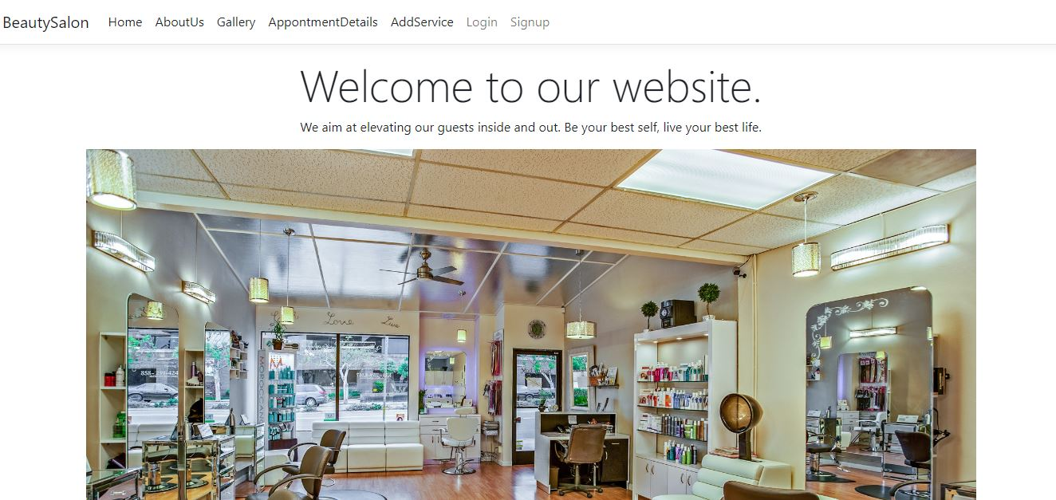

**Signup Page**

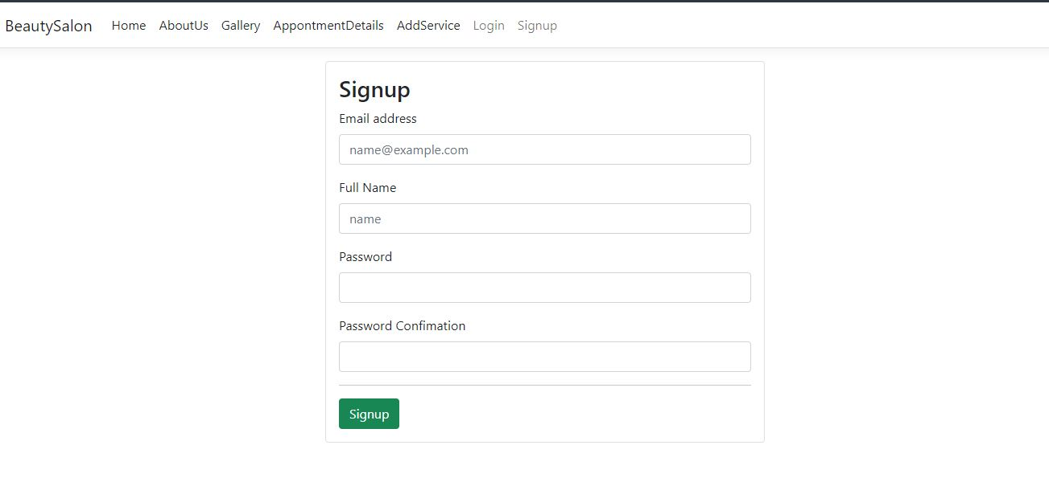

**Login Page**

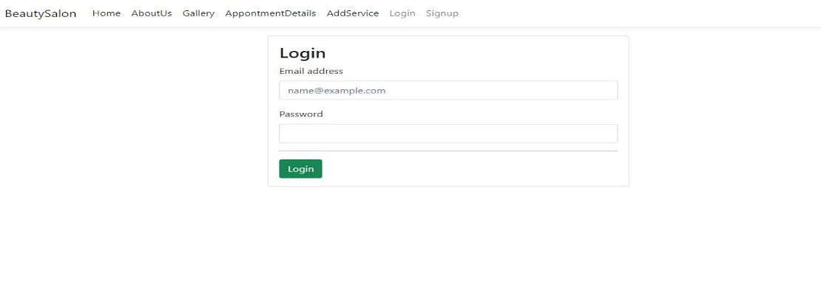

**AboutUs Page**

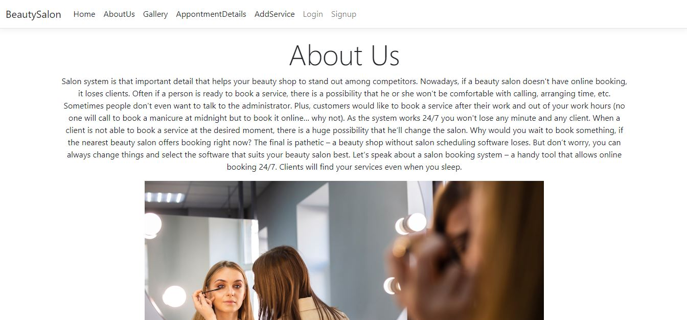

**AppointmentDetails Page**

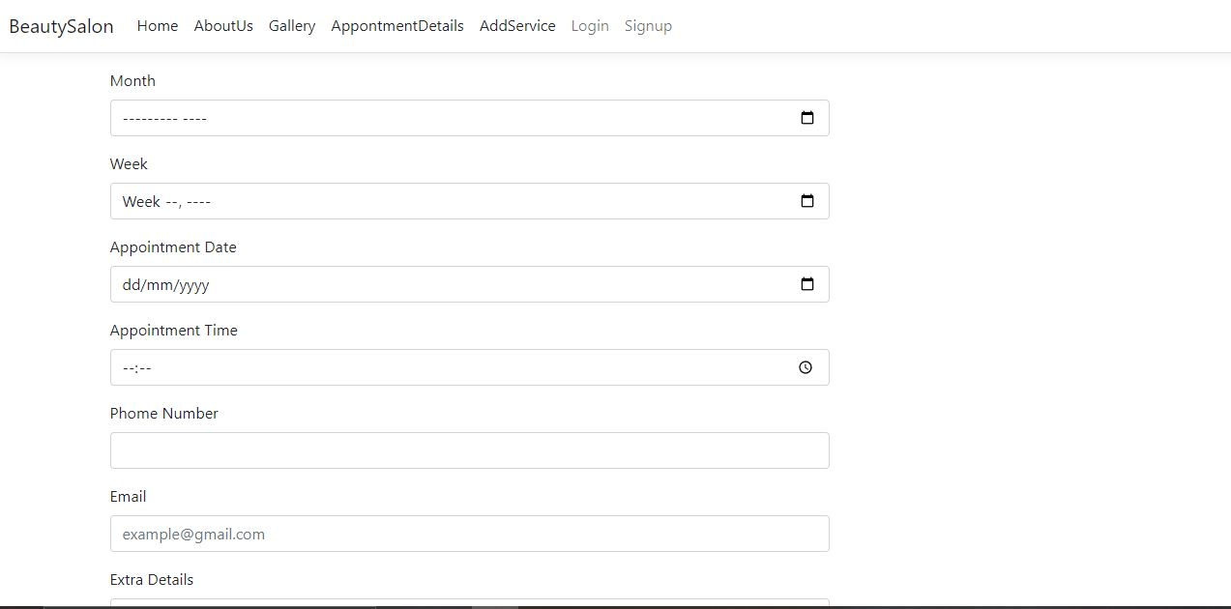

**AddService**

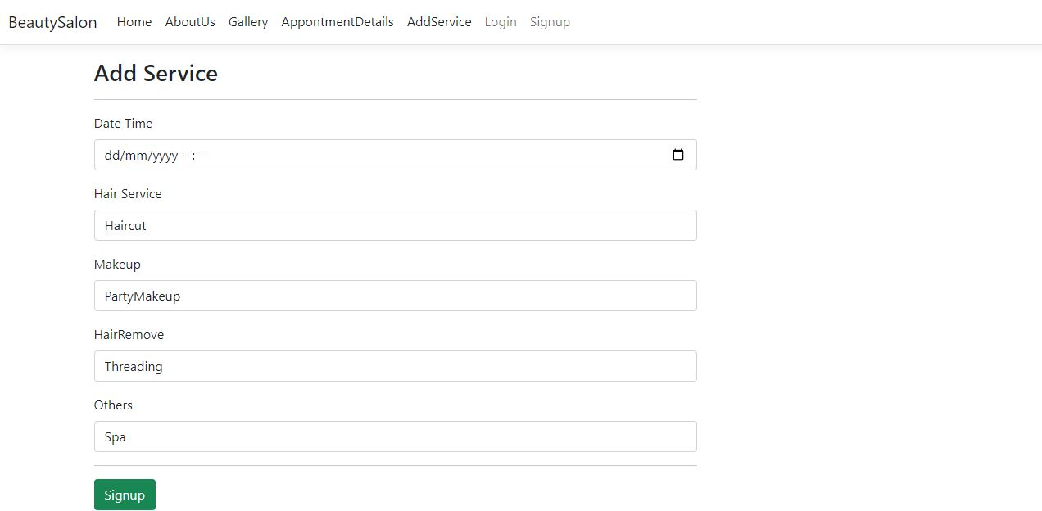

**Gallery**

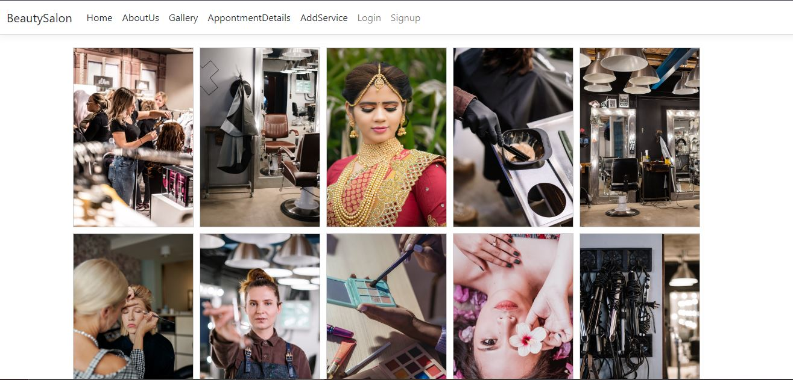

# **7. CONCLUSION**

Hence, in this way, In this lab session, we learnt about routing Model-View-Controller patterns, Razor pages, template inheritance, and so on. We also started a small project implementation of these concepts. This lab session focused primarily on MVC patterns, layouts, template inheritance, using views and rendering views using the Razor view. This lab session also marked the start of a project using ASP.NET core.